Assignment 4: Group Project Initialization
- Form your team (maximum 3–4 students) and fill in the team details in Teams.xlsx
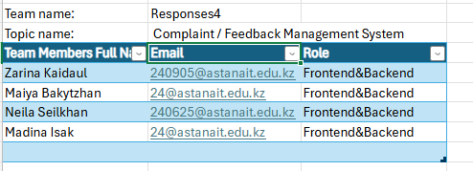
- Read the following documentation to understand what Django is and how to create a Django project:
https://tutorial.djangogirls.org/en/django/
- Install Django by following the official documentation:
https://www.djangoproject.com/
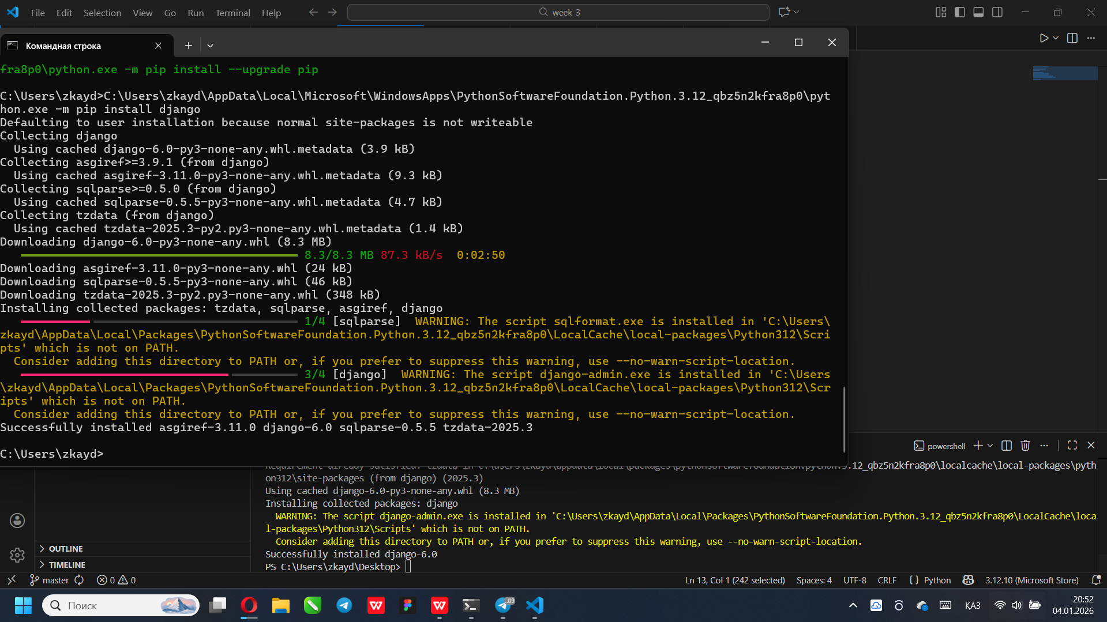

- Choose a project topic from Project titles.docx
15. Complaint / Feedback Management System
- Create an organization GitHub repository for your project by following this guide:
How to create git repository for the group project
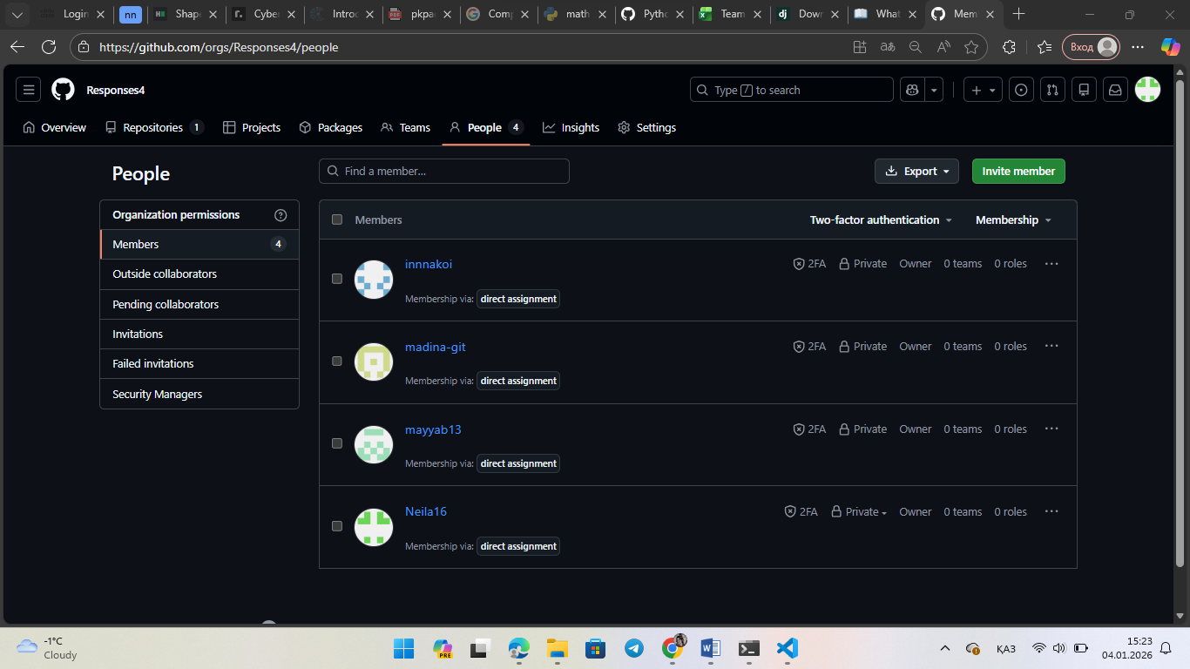
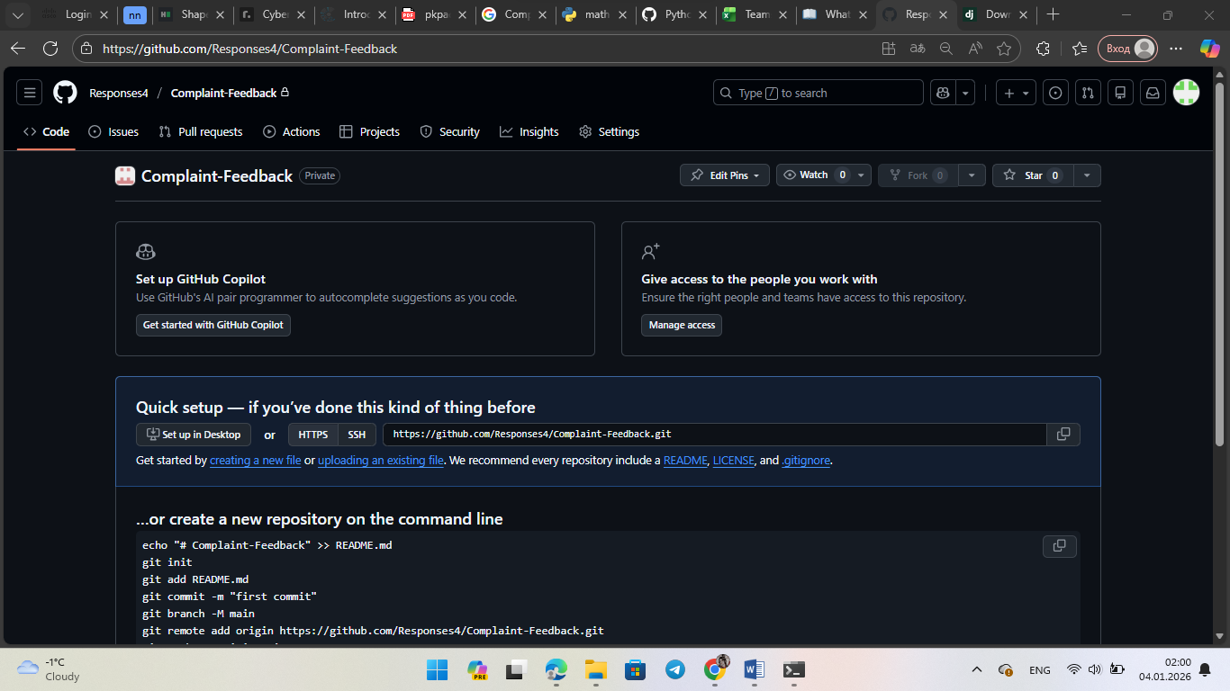
- Initialize your Django project (run it locally on localhost) and push the initial version to GitHub.
  - If you do not yet have team members, create the repository individually.
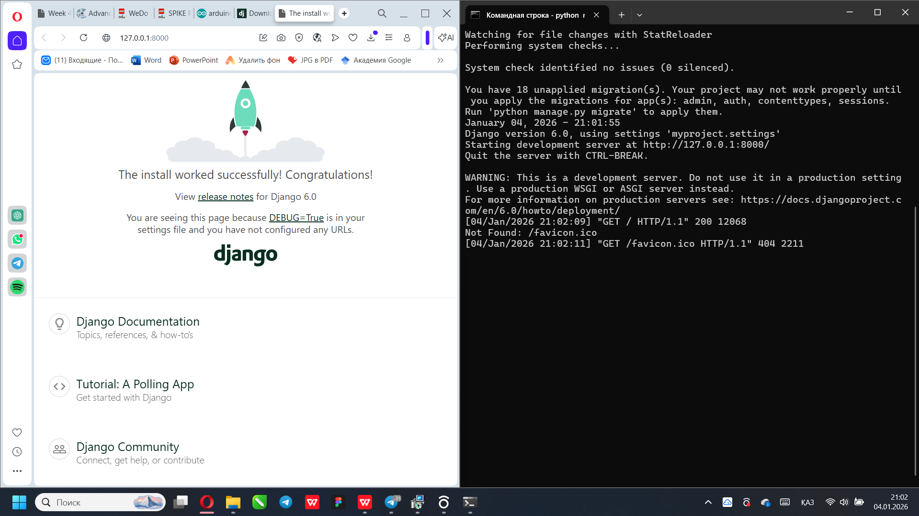
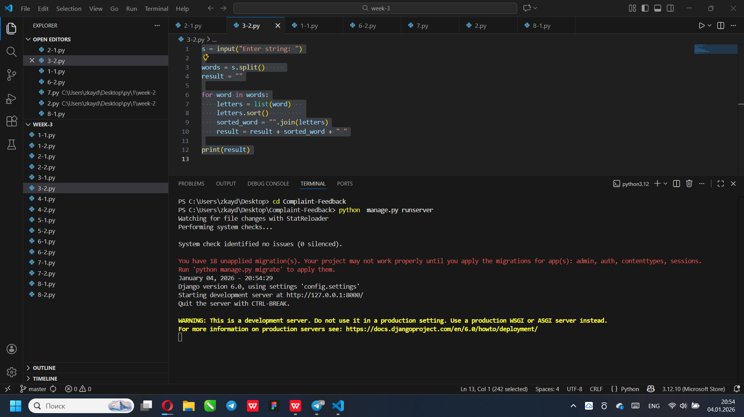
- Upload you link to GitHub project
https://github.com/Responses4/Complaint-Feedback.git

